**PSED**

Keeping safe

Respect for other cultures

Anti-bullying week

Giving and sharing at Christmas

Healthy and well-being

**RE**

*God Matters – Creation/ Advent & Christmas*

Remembrance Day

The Hindu religion-different beliefs

Prayer for Diwali

Looking at different cribs and Nativity pictures from around the world.

Oral story re-telling and extended writing– The Nativity Story

**Physical Development**

Developing fine and gross motor skills

Ball games – PE

Dance

**Home –School links**

Explore Indian food/spices

Talk about Christmas Story

Visit churches to see the different cribs and advent wreaths.

**Understanding the World**

Why we celebrate bonfire night

How to be safe with fireworks

To know about different cultural beliefs

Learn about India and the culture

Learn about how we and other cultures celebrate Christmas

Look at similarities and differences between cultures

Using iPads and computers

**Expressive Art and Design/ Being Imaginative**

Firework painting

Rangoli patterns

Mendhi hand patterns

Learning songs for Prayer service and Nativity

Retelling stories of Diwali and Christmas

Role play corner

Taking part in our nativity and prayer service

**Design and Make**

Design and make a firework

Clay Diva pots

Decorations

Biscuits

Presents

**Mathematics**

Sparkly numbers, number hunt

Counting to 20

Making Rangoli patterns

Make wrapping paper with repeating patterns

Sorting shapes

Ordering numbers and numicon

Weighing

Introduction to 5 frames

**Communication & Language/ Literacy**

Letters and sounds Phase 2 & 3 phonics

Tricky words/High frequency words

Reading books

*POR: Story of Rama and Sita, The Christmas Story*

The story of the Mendhi tree

The Jolly Christmas Postman

Mark making in glitter

Writing lists, cards, labels, letters

Writing stories

Using phonic knowledge to begin to write simple sentences

**WOW experiences:**

St Francis Prayer

service?

Our Nativity Play

St Nicholas Wow day

Let’s Celebrate!

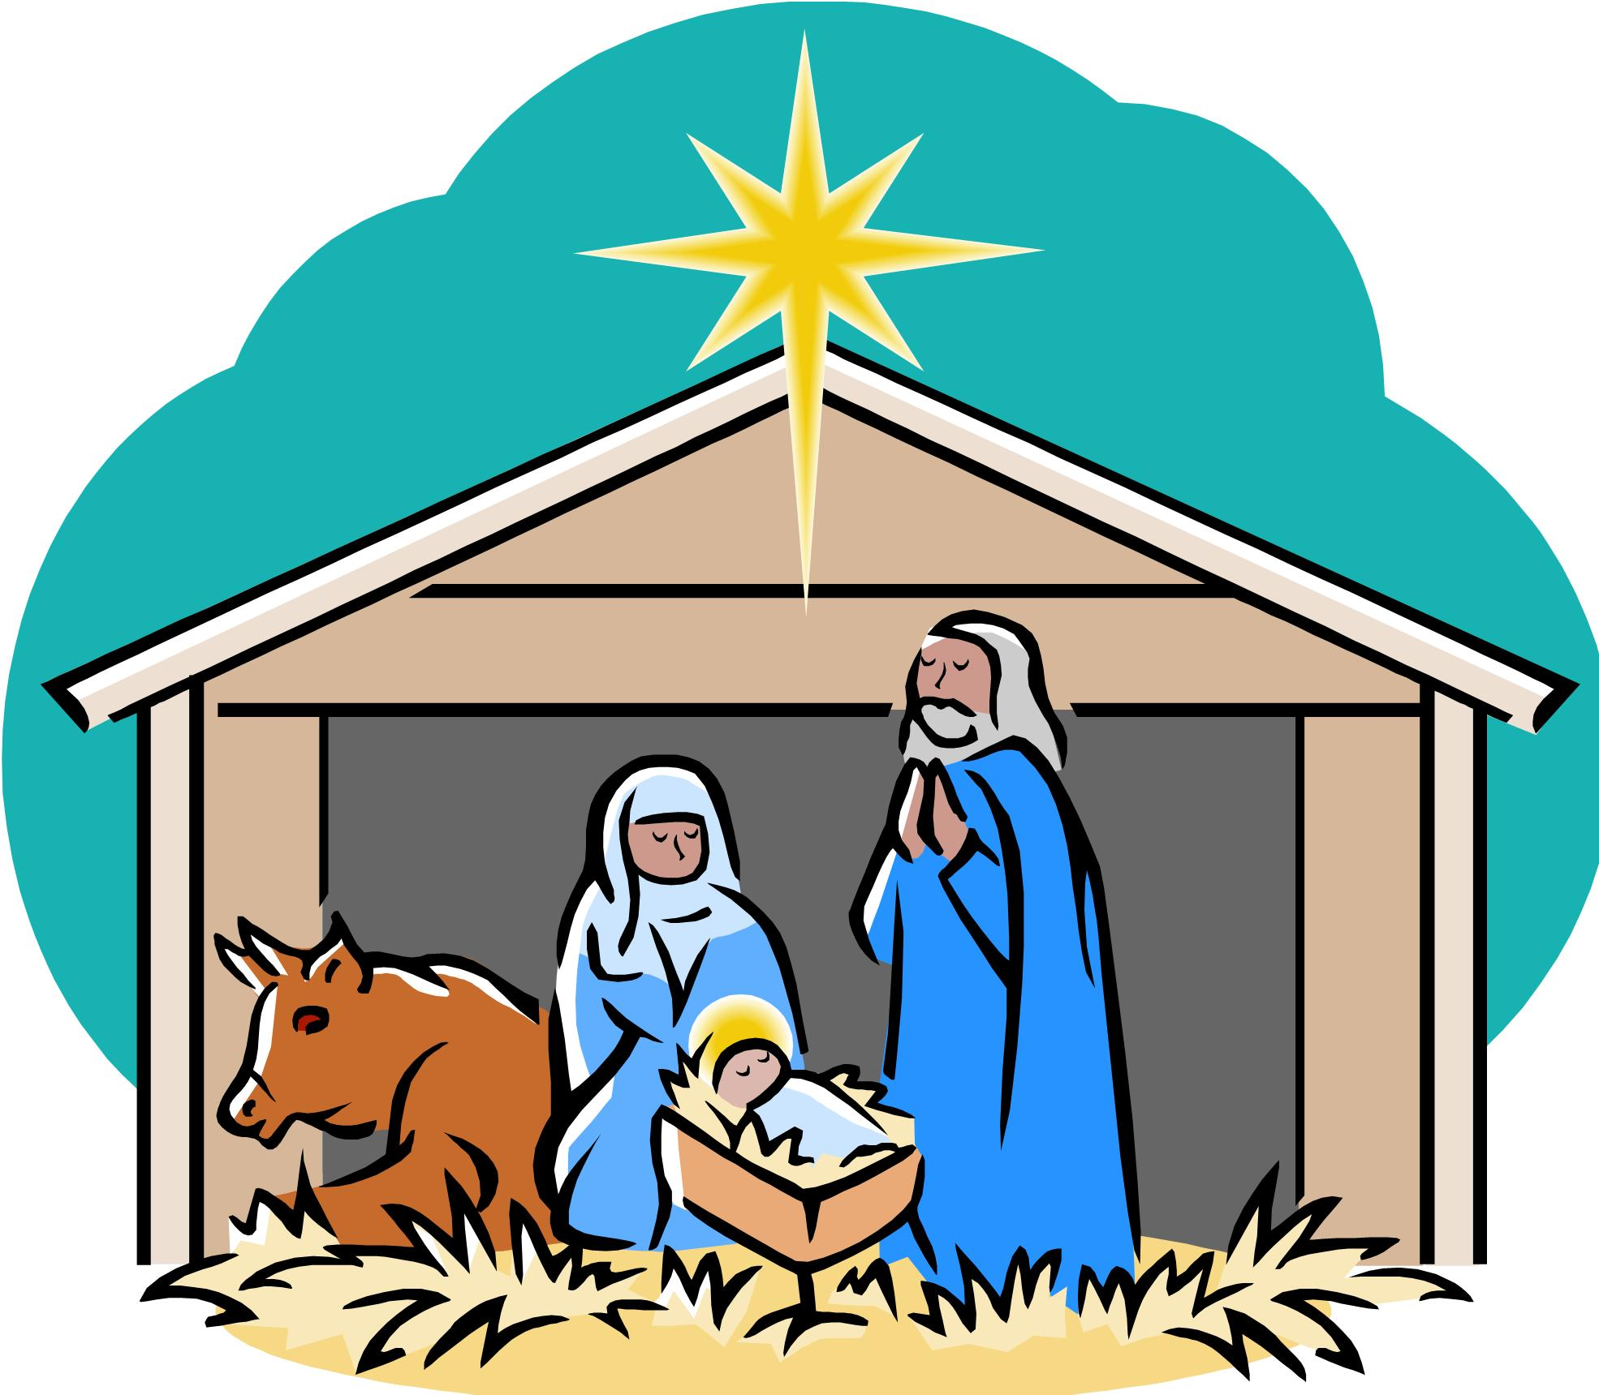 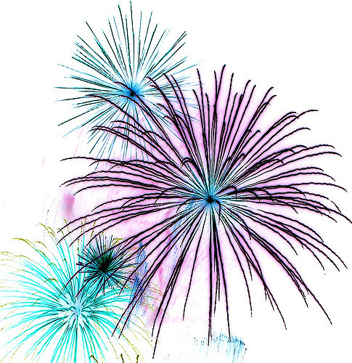 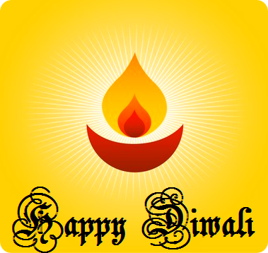

**Foundation Stage 2019-2020 Term 2**

*Sub topics: Fireworks, Diwali, Christmas*