 | St Joseph’s Catholic Primary School | 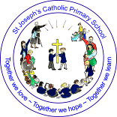
 | Swimathon Special!
 | Tuesday 5th April 2022

Dear Parents and Carers,
We are really proud of our swimathon team who took part in the annual Rotary Club swimming fundraiser.
Thanks go to Mrs Ravens for spending hours organising the event right at school and on the day.
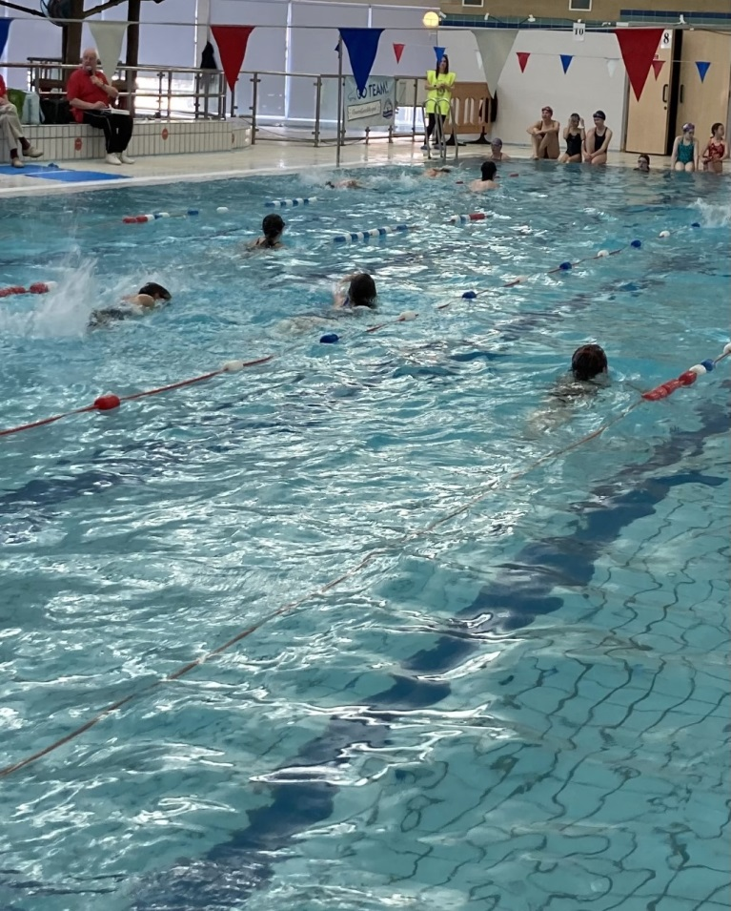
We had a fantastic turn out and the children were a credit to the school community and I would not be surprised if we had the largest team again – brilliant for our small family school!
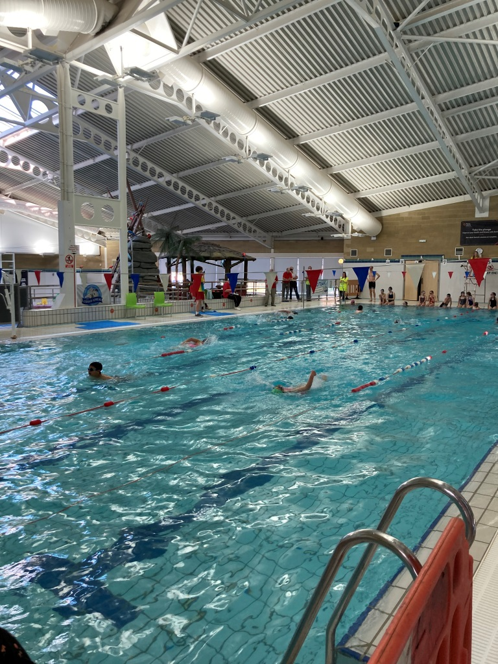
Thank you to the ex-pupils and parents who came back to support our school effort.
The children and parents managed to swim 675 lengths in total.
Year 3 – 54 lengths
Year 4 – 92 lengths
Year 5 – 138 lengths
Year 6 – 134 lengths
Year 7 – 81 lengths
Year 8 – 74 lengths
Parents – 102 lengths!
This was a school record for the number of lengths completed by our school team.
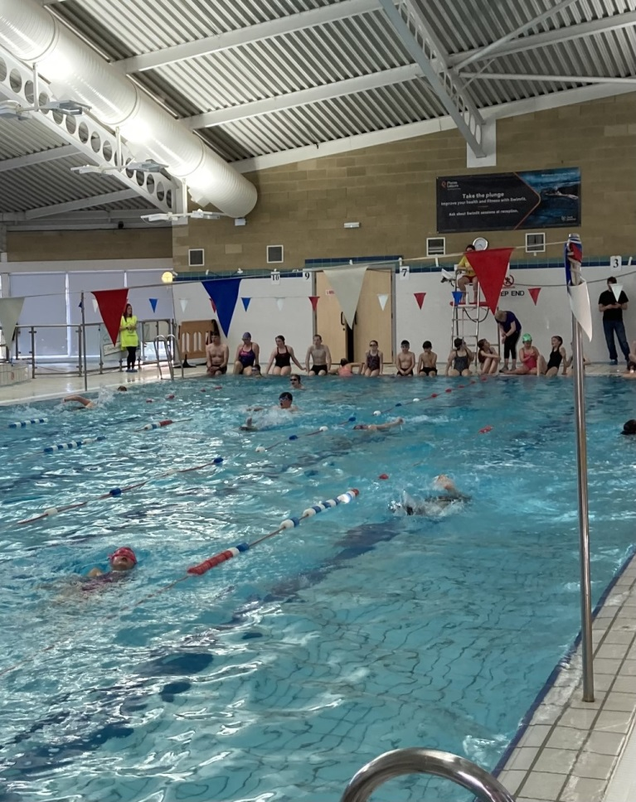
Thank you to the Rotary Club of Portishead for their efforts in organising this amazing event. We will update you on the funds raised for our school and for the Rotary Club charities.
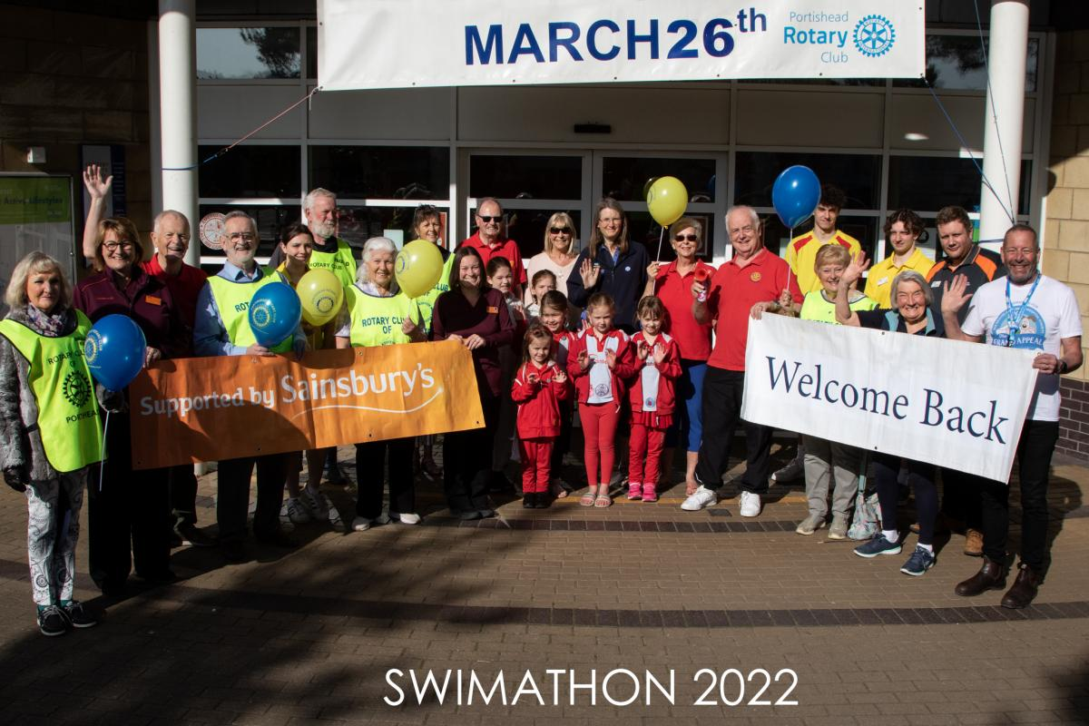
Keep the date for next year – Saturday 25th March 2023.
Well Done St Joseph’s!

Mr Bath
Headteacher

