



St Joseph’s Catholic Primary School

Parents Acceptable User Policy

September 2017
Review date September 2018

Parents are requested to sign the permission form to show their support of the school in this important aspect of the school’s work.

Parent/ Carer Acceptable Use Policy Agreement

New technologies have become integral to the lives of children and young people in today’s society, both within schools and in their lives outside school. The internet and other digital information and communications technologies are powerful tools, which open up new opportunities for everyone. These technologies can stimulate discussion, promote creativity and stimulate awareness of context to promote effective learning. Young people should have an entitlement to safe internet access at all times.

This Acceptable Use Policy is intended to ensure:
• That young people will be responsible users and stay safe while using the internet and other communications technologies for educational, personal and recreational use.
• That school ICT systems and users are protected from accidental or deliberate misuse that could put the security of the systems and users at risk.
• That parents and carers are aware of the importance of e-safety and are involved in the education and guidance of young people with regard to their on-line behaviour.

The school will try to ensure that pupils will have good access to ICT to enhance their learning and will, in return, expect the pupils to agree to be responsible users. Pupils will receive e safety education to help them understand the importance of safe use of the internet.

The school will take every reasonable precaution, including monitoring and filtering systems, to ensure that young people will be safe when they use the internet and ICT systems.
The school cannot ultimately be held responsible for the nature and content of materials accessed on the internet and using mobile technologies which has not been set by the teacher.
The pupil’s activities on the ICT systems will be monitored and that the school will contact the parent or carer if they have concerns about any possible breaches of the Acceptable Use Policy.
Pupils will be encouraged to adopt safe use of the internet and digital technologies at home and will inform the school if I have concerns over my child’s e-safety.

The school will comply with the Data Protection Act. We will also ensure that when images are published that the young people cannot be identified by the use of their full names.

A copy of the Pupil Acceptable Use Policy is attached so that parents / carers will be aware of the school expectations of the young people in their care.



St Joseph’s Catholic Primary School
Rules for Responsible Internet Use Foundation Stage

This is how we stay safe when we use Computers:

I will ask an adult if I want to use the computer. | 
I will only use activities that an adult has told me to use. | 
I will take care of the computer and other equipment. | 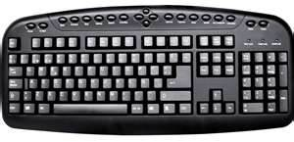
I will ask for help from an adult if I am not sure or have done something wrong. | 
I will press hector and tell an adult if I see something that upsets me on the screen. | 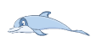
I know that if I break the rules I might not be allowed to use a computer. | 

Key Stage 1 Acceptable User Policy
I will only use my log in name to get on the computer. | 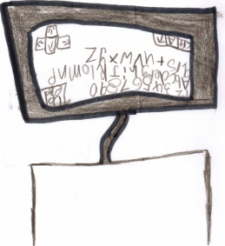  Designed by Caitlin
I will look after the computers and iPads. | 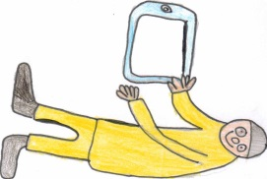  Designed by Lucas
I will do my best work which can be checked by an adult at any time. | 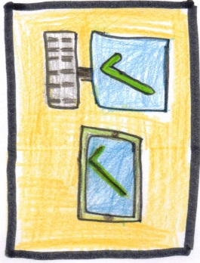  Designed by Casper
I will click on Hector or tell an adult if there is something I don’t like. |   Designed by Caisey
I will only use the programmes which my teacher has asked me to use. | 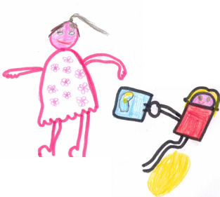  Designed by Jemima and Nancy
I will not share my personal information like my full name, phone number or address. | 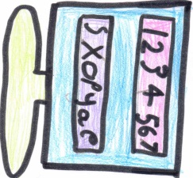  Designed by Sophie

for Computers and iPads


Key Stage 2 Acceptable User Policy
for Computers and iPads
I will ask an adult before using the Internet or gaming APP. | 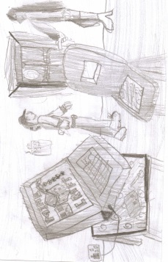  Designed by Oscar
I will always play fairly and treat the equipment with respect. | 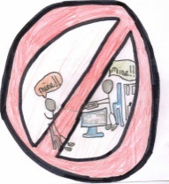  Designed by Jaz
I will only write appropriate messages which are polite and sensible. | 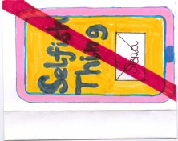  Designed by Zsuzsa
I will keep my password strong by including a capital letter and a number.  I will make sure it isn’t too long. | 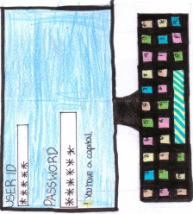  Designed by Poppy
I will only go on what I have been told.  I will not change the settings or click on any pop ups. | 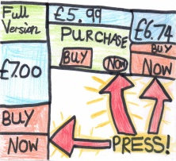  Designed by Sam
I will not share my password or other personal information such as my home address, full name and phone number. | 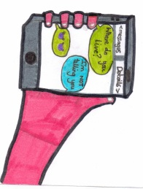  Designed by Rupert
I will click on Hector or tell an adult if I see something that I do not like. |   Designed by Vally
I will not copy work from the Internet and say it is my own work. | 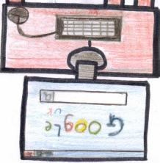  Designed by Bertie
I understand the school monitor the computers and can check what I do. | 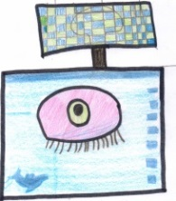  Designed by Melody
Signed by the Governing body ………………………………………… Date……………………

Review date……………………………………………………………..

