COMMUNICATION AND
LANGUAGE AND LITERACY
Phonics: Letters and Sounds Phase 3
POR "Owl Babies" Story
"Emperor's Egg"
"Ringo the Flamingo"
Story mapping and writing stories
Make class information book about owls.
Curriculum links:
Writing with a quill.
Mark making with feathers.
Non- fiction books about birds
Drama: Moving/thinking about birds
UNDERSTANDING THE WORLD
Life cycle of birds
Labelling birds
Tuff spot – Small birds world / bird puppet theatre.
Planting seeds for Mother’s Day
WOW Experiences:
Visit from Rose and Lloyd - Birds of Prey
Science Experiment: Humpty's Egg
Science Experiment How do animals stay warm in winter?
Building Tunnels (25th year of Channel Tunnel) Science Week
FOUNDATION STAGE PLANS 2018-19
Please note: This is plan is subject to change depending on ideas brought forward by the children and other external stimuli.
Terms 4
Topic: Through the Window
Sub Topic: Birds
Duration: 6 weeks

MATHEMATICS
See separate Small Steps Planning
Curriculum links:
Data handling Favourite birds
Counting birds
Weighing birds' eggs
Measuring penguins
Home-School Links:
Bird Watching - why not take part in the Big Garden Bird Watch Survey (see RSPB website for details)
ESD/outdoor learning
Looking after birds.
Wellie walks – bird spotting
BIRDS
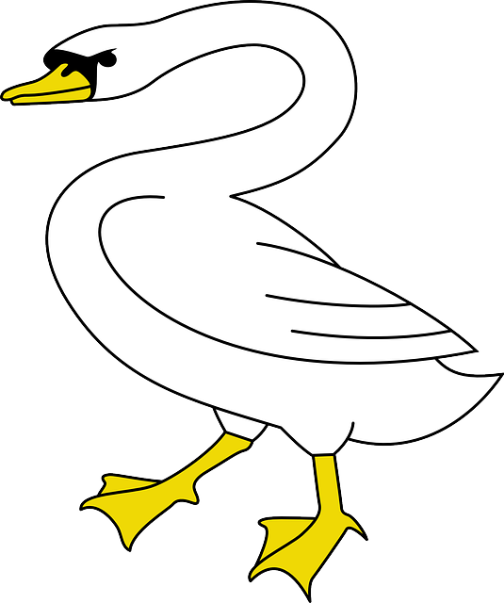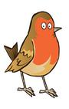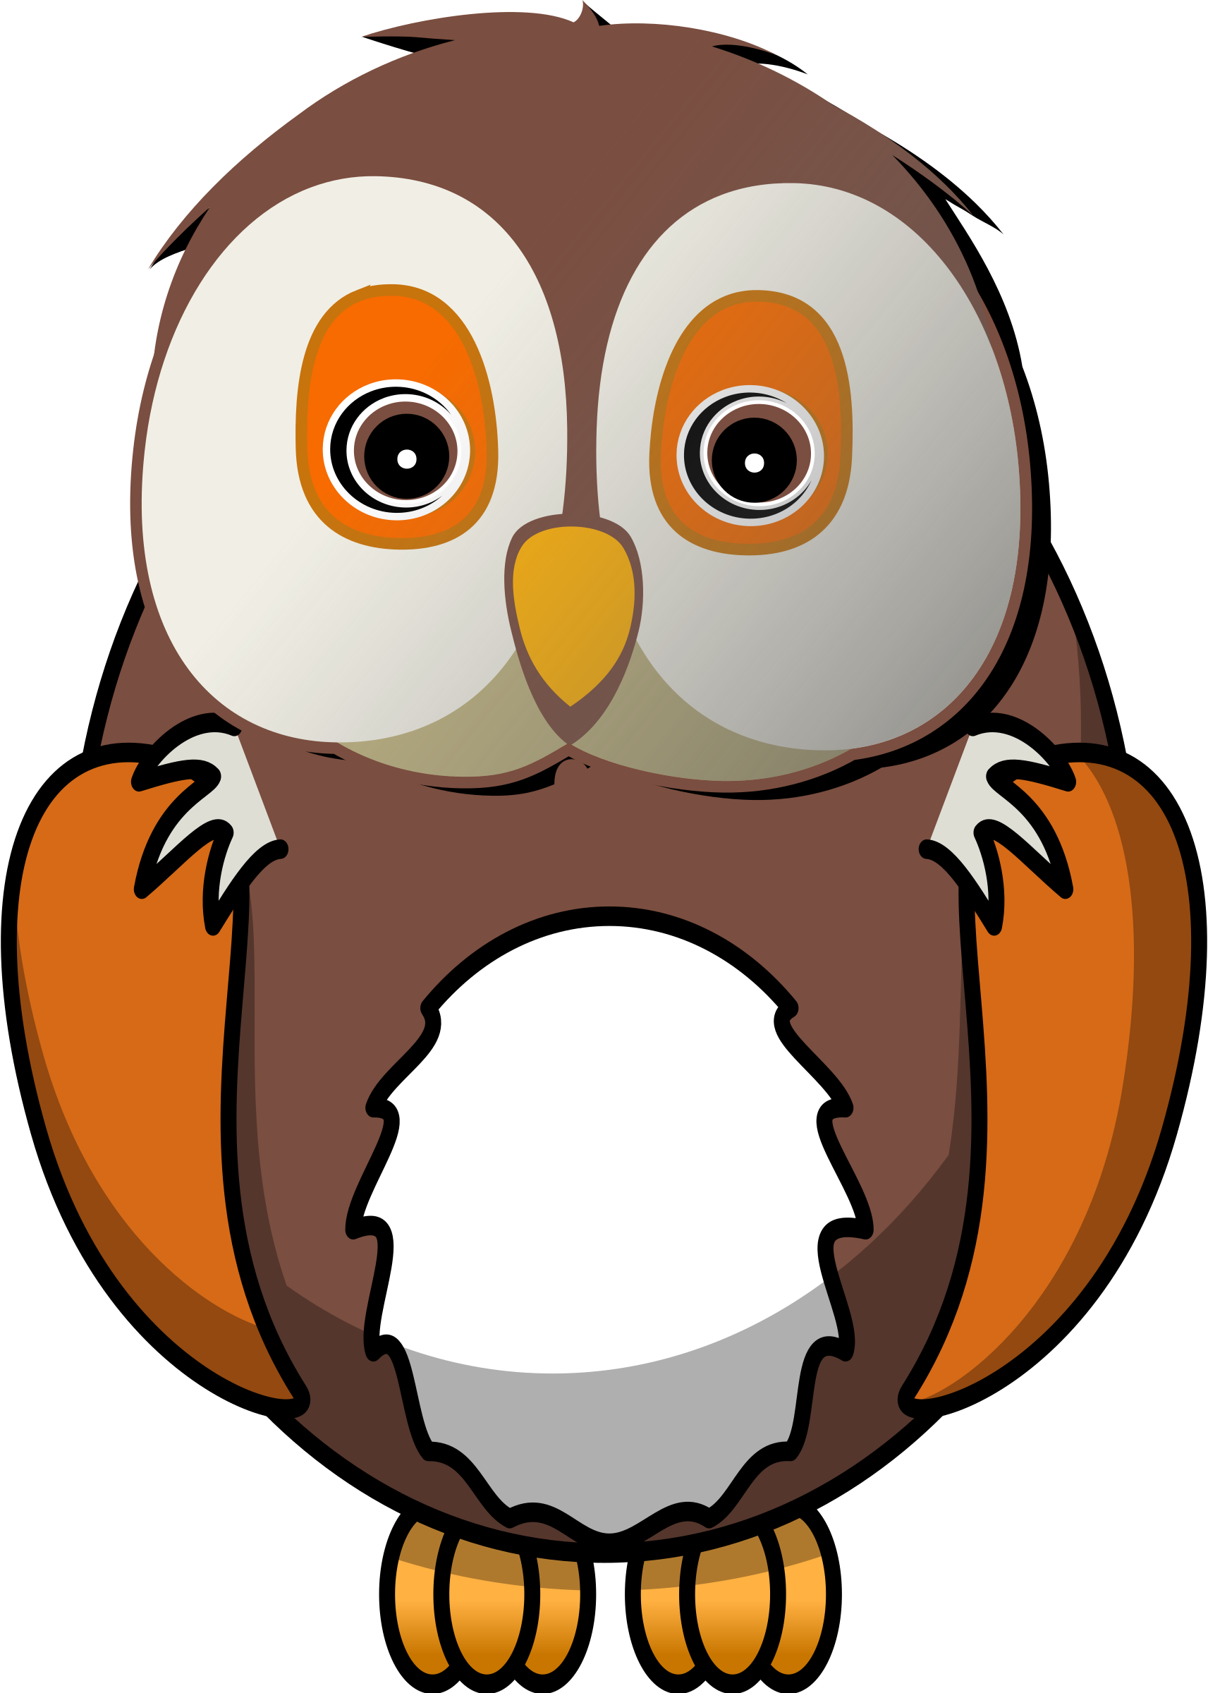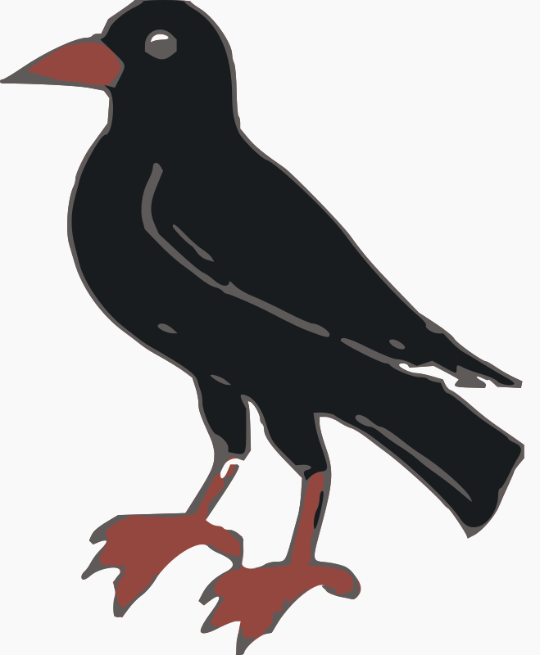
INFORMATION TECHNOLOGY
Log on to a computer and use simple programs.
RSPB website for activities
Using apps on the I-pads

R.E.
God Matters - Lent
Shrove Tuesday
Ash Wednesday
God Matters – Holy Week
Making an Easter Garden
EXPRESSIVE ARTS AND DESIGN
Curriculum Links:
Model Dinosaurs & habitats (Science Week)
The Hungry Caterpillar Cookery (Science Week)
Making a chocolate bird nest.
Mothers Day Cards
Make an Easter basket.

PHYSICAL DEVELOPMENT
Ball Skills SOW
Curriculum link:
Dance/move like different birds penguins etc
PSED-
SEAL Unit 4 Going for Goals
Knowing Myself
Setting a realistic goal
Planning to reach a goal
Persistence
Evaluation and review

