m
English
We will start a new book ‘The Lost Thing’
The Lost Thing is a humorous story about a boy who discovers a bizarre-looking creature while out collecting bottle-tops at a beach. Having guessed that it is lost, he tries to find out who owns it or where it belongs, but the problem is met with indifference by everyone else, who barely notice it’s presence.

Year 5’s objective is to publish a ‘quest’ story with the quest being to help someone of something to be accepted by others.
Grammar
- Recapping the year 5 grammar objectives

Weekly spellings, handwriting and reading comprehensions

Maths - measurement, converting units and volume
- Convert between different units of metric measure [for example, km and m; cm and m; cm and mm; g and kg; l and ml]
- Understand and use approximate equivalences between metric units and common imperial units such as inches, pounds and pints.
- Solve problems involving converting between units of time.

- Times tables challenge sheets.

.

History and Geography
A local study of Portishead - we will look at the changes that have taken place over time using evidence from maps, photographs and public records.

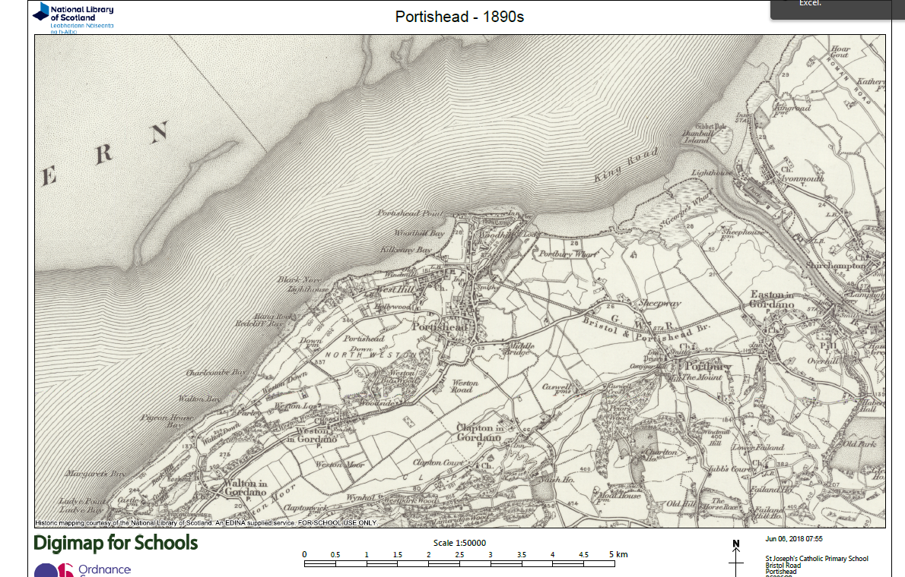

Science
Animals – including humans (biology) and living things and their habitats.
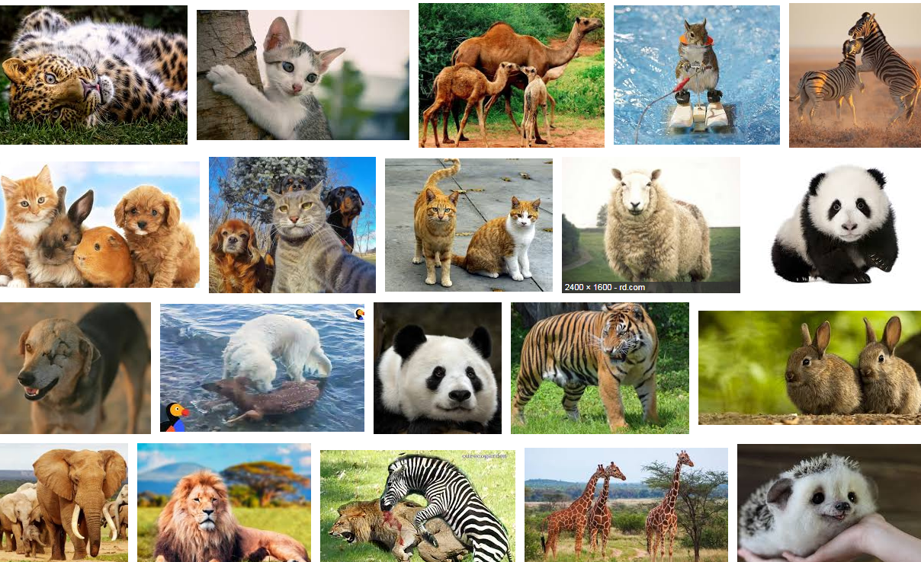

Music
Year 5 will continue music lessons with Mrs Page on Thursdays.

We will also be learning to play the clarinet as a part of the ‘Wider opportunities’ scheme provided by North Somerset. Children will each have access to their own clarinet with weekly lessons with Miss Laken and Miss Clough (alternating each Friday- W/c 23rd Apr)
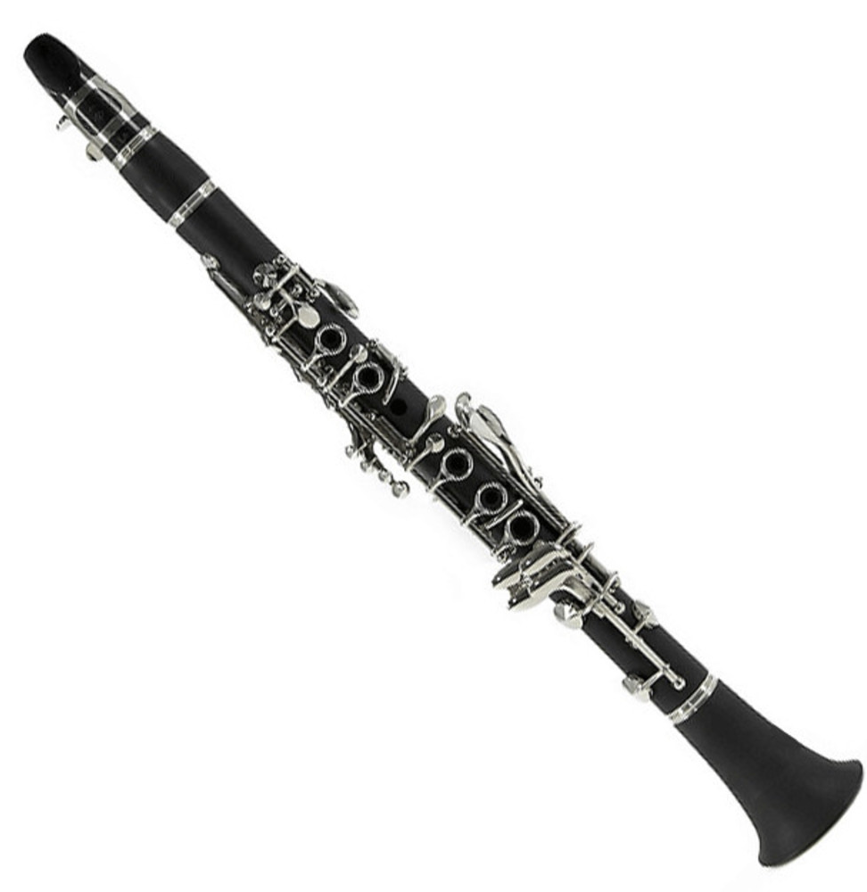

DT
Design and make, dress and evaluate different types of Greek salad.
Art
Study, make and decorate Greek pots.

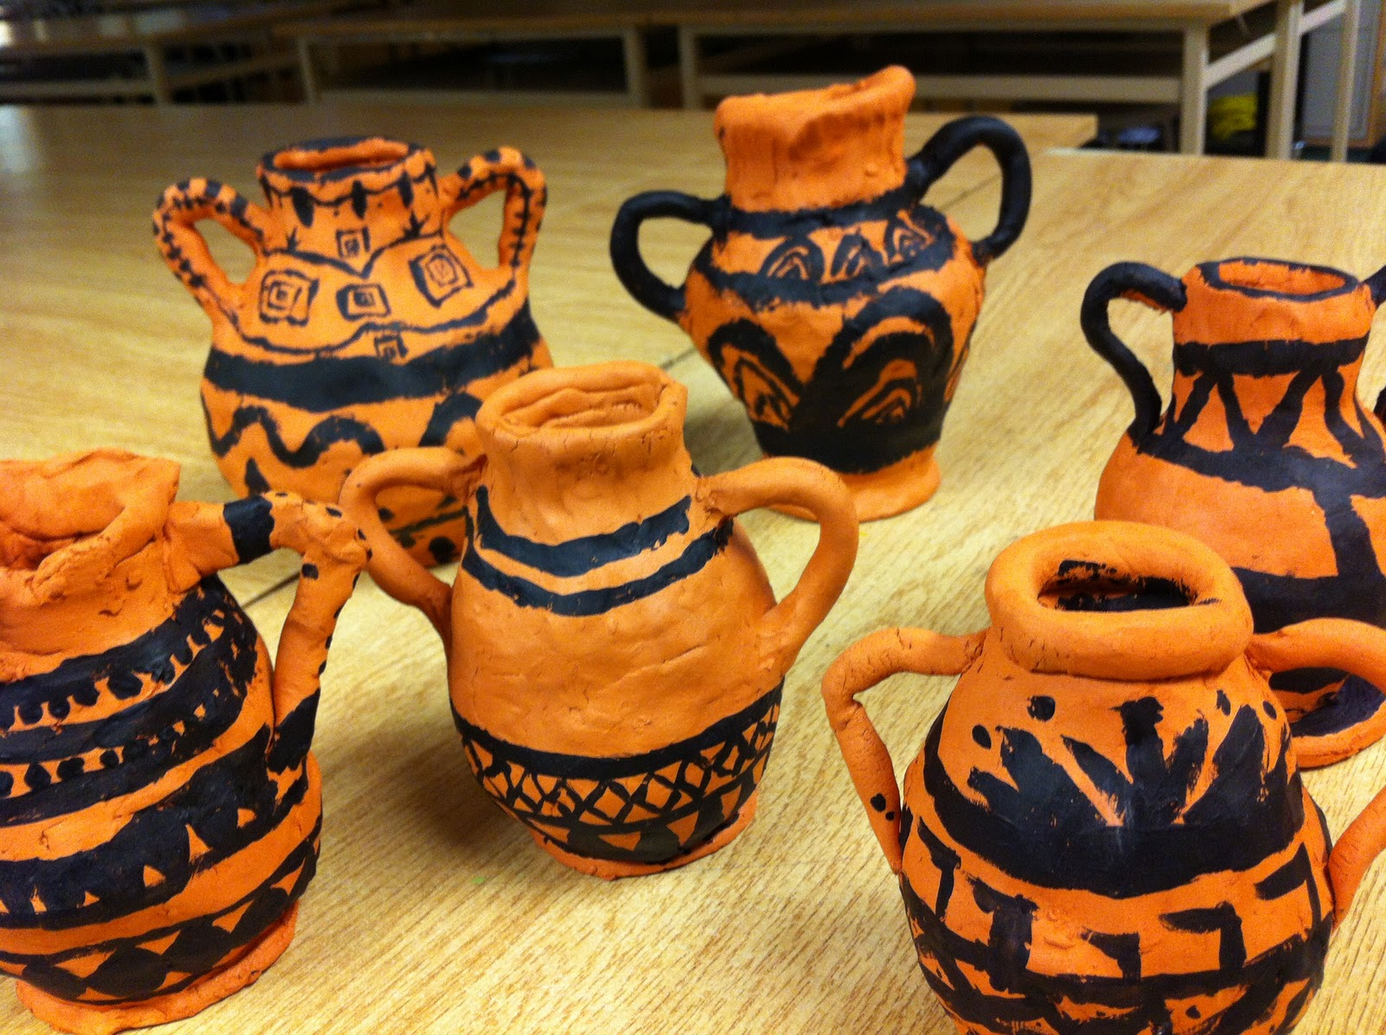
RE
Pentecost and Mission
Pupils are invited to consider the universal nature of the church by identifying the range of people represented in the account of Pentecost. Pupils will explore how they can be disciples of Jesus.

PE
PE with Miss Laken – summer sports
Kwik cricket – Mrs Geary

PSHE
EPR – Journey in Love

Spanish
Year 5 will continue their Spanish lessons with Miss Laken.

Computing
E safety –
Picture perfect

Year 5
Term 6

