DESIGN AND MAKE (linked to EAD)
Make a Chinese dragon.
Make a Chinese lantern
Make a Chinese fan
Look at Chinese patterns and paintings to create own including looking at the willow pattern
CHINESE NEW YEAR
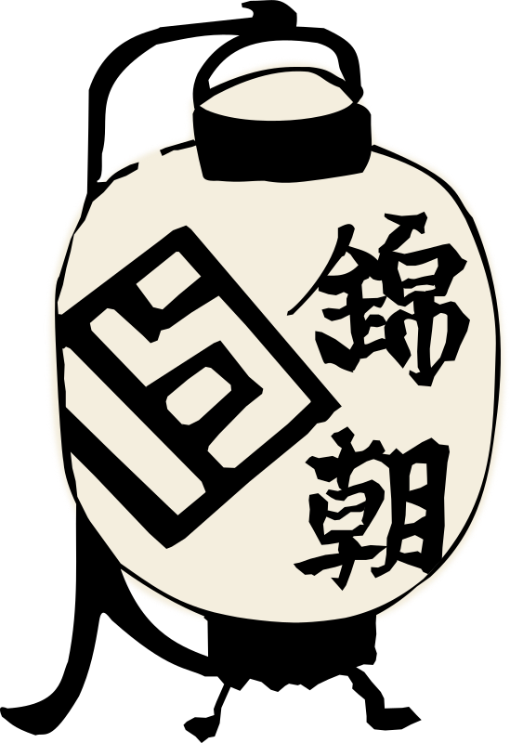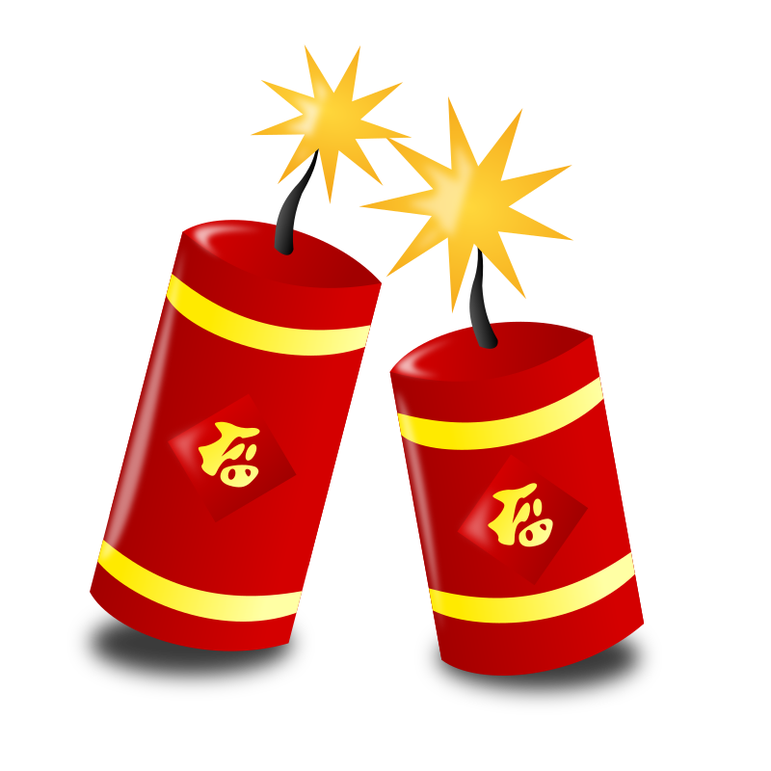
INFORMATION TECHNOLOGY (UTW)
Computers: Learning how to turn on a computer independently and log in using own username.
I-pads: Using i-pads to look at pictures and maps of China
EXPRESSIVE ARTS AND DESIGN
Painting with calligraphy brushes.
Cooking and tasting noodles and other Chinese food
Role play – ‘The story of the Chinese zodiac’.
The Chinese lion dance with lion mask.
Mask making
PSED
SEAL Unit 4 Going for Goals
Respect for other cultures
PHYSICAL DEVELOPMENT
Gymnastics
Curriculum links: The Chinese lion dance and using chopsticks.
RE
God Matters Revelation and Lent
Children will learn about different artefacts in a church and the events, religious symbols and stories related to Lent. St David, St Patrick and Mother’s Day Easter Story Extended Writing

ESD / outdoor learning
Endangered species e.g. panda
COMMUNICATION AND LANGUAGE AND LITERACY
Phonics Letter and Sounds Phase 3 digraphs
POR: ‘The Magic Paintbrush’ by Julia Donaldson
Children will be writing a version of the story, labelling Chinese artefacts and writing instructions.
Other books: C is for China story.
Made in China –by Deborah Nash
The story of the Chinese Zodiac
Chinese New Year’s dragon by Rachael Sing Role Play: A Chinese Restaurant

KNOWLEDGE AND UNDERSTANDING OF THE WORLD
Children will learn about cultural beliefs of people in China.
What is Chinese New Year? – How is it celebrated?
Look at China and its culture. – Looking at Chinese artefacts
Learning about China – where is it on a map? Looking at the pagodas and Great Wall of China
Cooking and eating noodles - using chopsticks
Science experiments: Dancing noodles and Floating rice
FOUNDATION STAGE PLANS 2017-18
Please note: This is plan is subject to change depending on ideas brought forward by the children and other external stimuli.

Term 4
Topic: Let's Celebrate
Sub topic: Chinese New Year
Duration 4 weeks
MATHEMATICS
Children will be exploring 3D shapes, patterns and teen numbers.
Practise number formation
Topic Links: Writing numbers in mandarin and making tangrams.
Home Links
Look at Chinese New Year across all areas of the curriculum

