Year 6 Term 6 Overview
English  integrate dialogue to convey character and advance action  distinguish between language of speech and writing and choose appropriate register  different levels of formality  Persuasive writing – to governors about planting trees | Maths  NRich investigations  Spirals investigation  profit and loss – Business Fayre | Science The Carbon Cycle, measuring amount of carbon captured by the trees in the school grounds. Importance of trees for the environment
RE  To explore different types of prayer at our retreat day.  Pentecost and Mission  How the gifts of the Holy Spirit bear fruit in our lives. How sacrament of confirmation can shape our lives. How the gifts of the Holy Spirit  Multifaith To explore the Hindu belief of reincarnation | Year 6  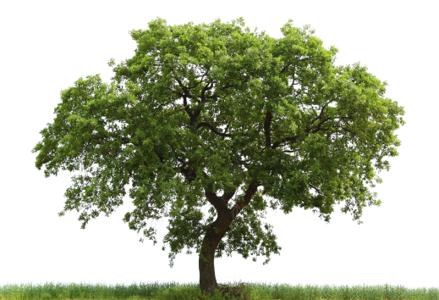 | Music  Children will learn and perform “Shakespeare Rocks”
Art
Sketching
complete Hockney paintings for those who haven’t
DT
Cook and eat a two course meal from scratch.

Computing E Safety  ICT Excel spreadsheets | Geography / History  The History of Bristol  Children to choose an aspect of Bristol’s history to research for extended learning.  Landscapes and settlements | PE  Rounders Kwik cricket  Ultimate Frisbee Danish long ball,  SportsWeek – orienteering, dance, fencing and athletics
PSHE – SEAL –Change – different types of change, positive and negative and common human responses to it
develop children’s ability to manage and understand feelings associated with change.
Journey in Love -Changes in the human body
Spanish
Song

